E-POSTER UPLOAD GUIDELINES

Instructions for E-Poster Display

How do I prepare my E-Poster?
You must first prepare a poster prior to uploading your E-Poster

Step 1:
Prepare a one page poster document in power point or word document. You may download a template to prepare an e-poster.
In order to download the e-poster template please click this link. (to click the link use CTRL key)
Step 2:
Turn your document into PDF format.

- All ePosters should be prepared in English.
- Layout: Portrait (vertical orientation)
- Poster Size:
- Pixels: Minimum recommended size (format W x H) is 1125 x 2000px and maximum is 2250 x 4000px.
- Format: 9:16
- DPI 300 pixels/inch
- File Size: Maximum file size is 4 Megabytes (4MB).
- File Format: Save your file as a PDF for quick and easy upload.
- Media: Images/photos, graphs and tables can be included in the ePoster.
- Multimedia: Videos, music and personal QR codes cannot be included in the ePoster.

How do I Upload my e-poster?

Step 1:
Open your internet browser (preferable Chrome, Firefox or Safari) and go to the E-Poster submission site.

Step 2:
Enter your personal access information (username and password). The personal access information has been provided to you through email. Click on “Log-in”.
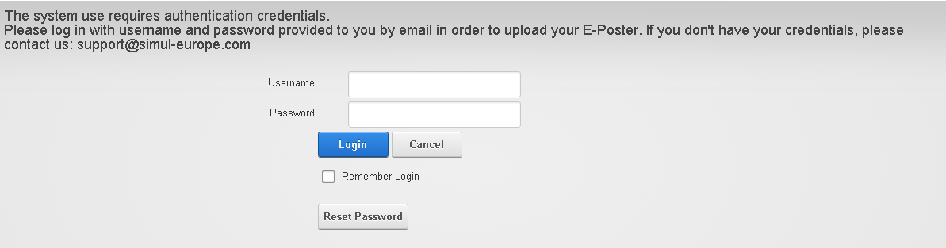

Step 3:
Please read the Terms and Conditions. If you agree with the Terms and Conditions, click on the box “I agree”.

Note: If you do not agree with the terms and conditions, it will not be possible to upload the e-poster.

Step 4:
Click “Edit” button to change ePoster text and upload the file.
If you have 2 or more ePosters, you will see them in one table and each one of them can be edited separately.
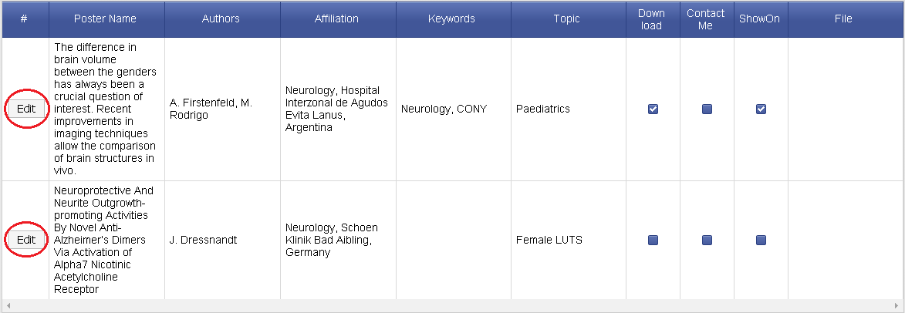

Step 5:
Check all details of your ePoster
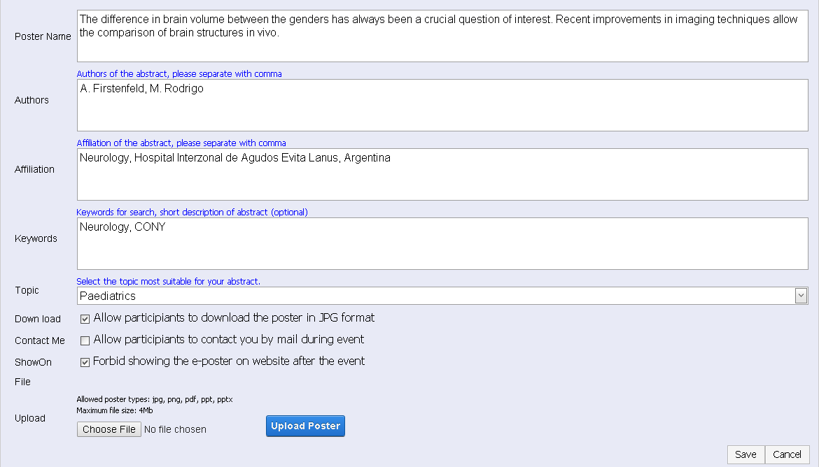

If you would like to give permission for other participants to download a copy of your e-poster (in JPEG format), please make sure there is a check mark next to “Downloadable”.

If you would like to give permission for other participants to contact you during a meeting, please make sure there is a check mark next to “Contact Me”.

If you would like to deny permission for other participants to see your ePoster after a meeting, please make sure there is a check mark next to “Don’t Show on Website”.

Step 6:
Click on the “Browse” or “Choose File” button and select your file from your computer.
Please make sure the file you trying to upload contain only English characters or numbers.
Note: You can only upload files that are in PDF format.

Step 7:
Click on “Upload” and wait till the poster is uploaded. Short message will appear after successful upload.

Step 8:
Click “Save” to update the database.
On successful update you will see added file in “File” section.
You can view uploaded files by clicking on file or “View File” button.
Most files will be shown online except PowerPoint which will be downloaded.
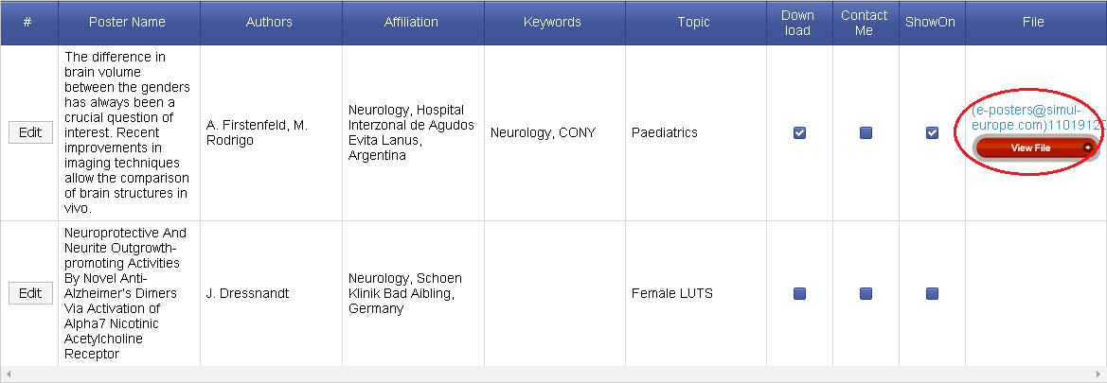

Please make sure the file you are uploading is correct. If you upload the wrong file, please click “Edit” again and return to step 6.

