Professor Yaakov Nahmias

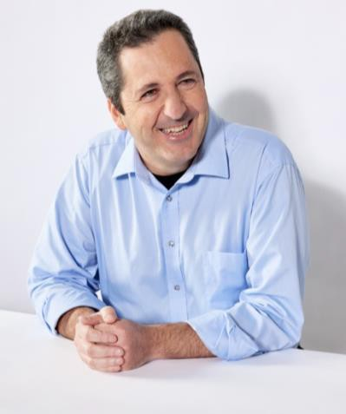
Professor Yaakov “Koby” Nahmias is the Founder, President, and Chief Science Officer of Believer Meats, (formerly known as Future Meat Technologies) and the Founder and CSO of Tissue Dynamics. Nahmias is also a professor at the Hebrew University of Jerusalem, where he is the founding director of the Grass Center for Bioengineering and serves as a visiting professor at Harvard Medical School. An internationally recognized bioengineer, Nahmias has been the recipient of a NIH career award, two European Research Council (ERC) grants, the Kaye Innovation Award, and the Rappaport Prize in Biomedical Research, and the Rosetrees Trust Prize.

As an expert in tissue engineering and nanotechnology, Nahmias has led innovation in the first 3D cell printing and the first commercial human-on-chip technology on the market. Nahmias is a fellow of both the prestigious American Institute for Medical and Biological Engineering (AIMBE) and the British Royal Society of Medicine (RSM); an editorial board member of the Annual Reviews for Biomedical Engineering; and a long-standing member of the European Research Council LS9 Biotechnology committee. Nahmias is a professor at the Hebrew University of Jerusalem, where he is the founding director of the Grass Center for Bioengineering.

Nahmias holds a PhD in Biomedical Engineering from the University of Minnesota and a BSc in Chemical Engineering and Biology from Technion Israel Institute of Technology.

